Seabob Data Exploration (2013-2019)

Seion Richardson

7/13/2019

**Table of Contents**

1 Data codes and meaning 3

2 Data description 3

3 Summary statistics for selected variables within dataset 3

3.1 Raw weight 3

3.2 Peel weight 4

3.3 Correlation between selected variables 4

4 Scatter plot of seabob catch against days-at-sea. 4

5 Smoothed line plot of seabob catch against days-at-sea. 5

6 Analysis of seabob biomass 6

7 Cumulative frequency plots of shrimp size classes 7

8 Plot of seabob size distribution by company. 8

9 Data plots against the Reference Points 8

9.1 By Company 9

9.2 By month 9

10 Analysis of fishing effort 10

10.1 Days-at-sea annual distribution 10

10.2 Average days-at-sea by company 11

10.3 Trip distribution by nominal days-at-sea 12

10.4 Trip distribution by months 12

10.5 Trip distribution by years 13

11 ANALYSIS OF CATCH AND EFFORT (JANUARY TO APRIL) 14

12 Biomass 14

13 Fishing effort 15

13.1 Trips 15

14 Fishing effort 16

14.1 Days-at-sea 16

15 Average days-at-sea by company from January to April (2013-2019) 17

16 Catch-per-unit-effort (biomass/effort) 17

# Data codes and meaning

no - Numbers  
com - Companies  
yr - Years  
mon - Months  
ves - Vessels  
dep - Departure dates  
arr - Arrival dates  
d - Days  
m - Months  
y - Years  
ndas - Nominal days-at-sea  
sdas - Standardised days-at-sea  
rwt - Raw weight  
pwtlb - Peel weight (pounds)  
pwtkg - Peel weight (kilograms)  
cpue - Catch-per-unit-effort

# Data description

The data was collected over a seven year period (2013-2019), from January to December, except for the closed season (August to October) and the year (January to April). Every row with the data represents a full fishing trip with corresponding departure and arrival dates and catch and effort statistics. The data was imported with 29 varibales and 14,142 obbservations. It was then filtered to remove extreme days at sea i.e. <3 and >15. This action removed a total of 157 row from the dataset. The data used in the analysis comprises the following variables of interest:

1. Companies  
 2. Vessels  
 3. Years   
 4. Months  
 5. Departure dates  
 6. Arrival dates  
 7. Catch   
 + Raw  
 + Processed  
 8. Effort (days-at-sea)  
 + Nominal   
 + Standardised  
 9. Catch-per-unit-effort (cpue)

# Summary statistics for selected variables within dataset

## Raw weight

## ndas rwt rwtcpue_lbs_ndas   
## Min. : 3.000 Min. : 104 Min. : 17.33   
## 1st Qu.: 6.000 1st Qu.:14702 1st Qu.: 1872.22   
## Median : 7.000 Median :19238 Median : 2546.17   
## Mean : 7.387 Mean :19121 Mean : 2741.02   
## 3rd Qu.: 9.000 3rd Qu.:23758 3rd Qu.: 3384.00   
## Max. :15.000 Max. :43516 Max. :13331.33

The nominal days-at-sea (ndas) for fishing vessels, ranged from 3 to 15 days-at-sea. Despite this large range both the mean and median days-at-sea were 7; indicating that they were fewer observations of the min and max values in the range. The raw weight landed also showed a similarly wide range of observations i.e. 104lbs:43,516lbs. These observations were very different from the observed mean and median (19,121 and 19,238) values, respectively.

## Peel weight

## sdas pwtkg pwtcpue_kg_sdas   
## Min. :2.680 Min. : 21 Min. : 3.85   
## 1st Qu.:5.450 1st Qu.:2996 1st Qu.: 497.46   
## Median :5.890 Median :3982 Median : 667.12   
## Mean :5.843 Mean :3964 Mean : 689.80   
## 3rd Qu.:6.430 3rd Qu.:4943 3rd Qu.: 849.52   
## Max. :6.890 Max. :8600 Max. :2948.15

The standardised days-at-sea (sdas) hereafter referred to as fishing days, ranged from 3 to 7 fishing days with the mean and median being 6 days, respectively. The peel weight landed ranged between 21 to 8,600 kg, with mean and median values of 3,964 kg and 3,982 kg, respectively. raw weight landed also showed a similarly wide range of observations i.e. 104lbs:43,516lbs. These observations were very different from the observed mean and median (19,121 and 19,238) values, respectively. Both the mean and median catch-per-unit-effort values were above the current target reference point (i.e. 630 kgs/sdas).

## Correlation between selected variables

## ndas rwt rwtcpue_lbs_ndas  
## ndas 1.000000000 0.007081128 -0.5236628  
## rwt 0.007081128 1.000000000 0.7975152  
## rwtcpue_lbs_ndas -0.523662805 0.797515171 1.0000000

## sdas pwtkg pwtcpue_kg_sdas  
## sdas 1.0000000 0.0114399 -0.3299550  
## pwtkg 0.0114399 1.0000000 0.9180005  
## pwtcpue_kg_sdas -0.3299550 0.9180005 1.0000000

Correlations tests were performed on the main catch and effort variables. Raw seabob biomass was tested against the corresponding ndas and cpue with the same approach taken for peel seabob biomass. The results for both groups of variables showed that there was a positive correlation between rwt/pwtkg and ndas/sdas. This meant that with increase effort a corresponding increase in catches were recorded. However, the opposite is true when ndas/sdas was checked against cpue.

# Scatter plot of seabob catch against days-at-sea.

The red broken line (vertical) represents the mean days-at-sea (7) and the blue broken line (horizontal) represents the TRP (19,000 lbs). A view of the side-by-side plots reveals some number of anomalies in the data e.g. few days-at-sea yielding unreasonably high catches and vice versa.

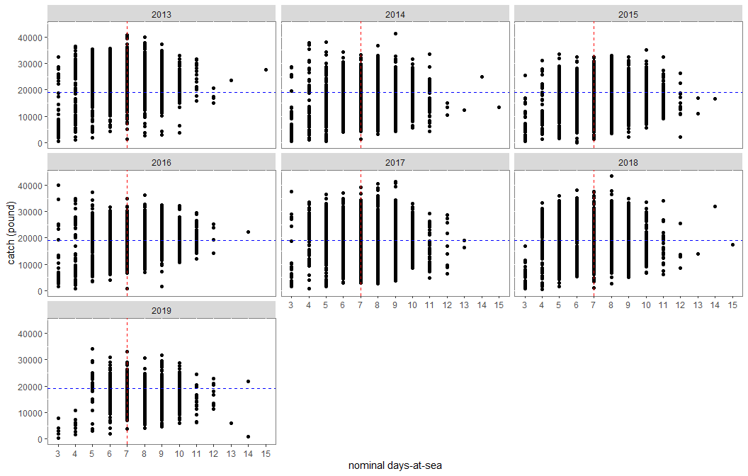

# Smoothed line plot of seabob catch against days-at-sea.

The red broken line (vertical) represents the mean days-at-sea (7) and the blue broken line (horizontal) represents the TRP (19,000 lbs). A view of the side-by-side plots revealed that there was an increase in catches as the length of trips increased i.e. for trips lasting for approximately 3-6 days on average. Whereas catches leveled off or gently increased after for trip lengths above 6 days.  
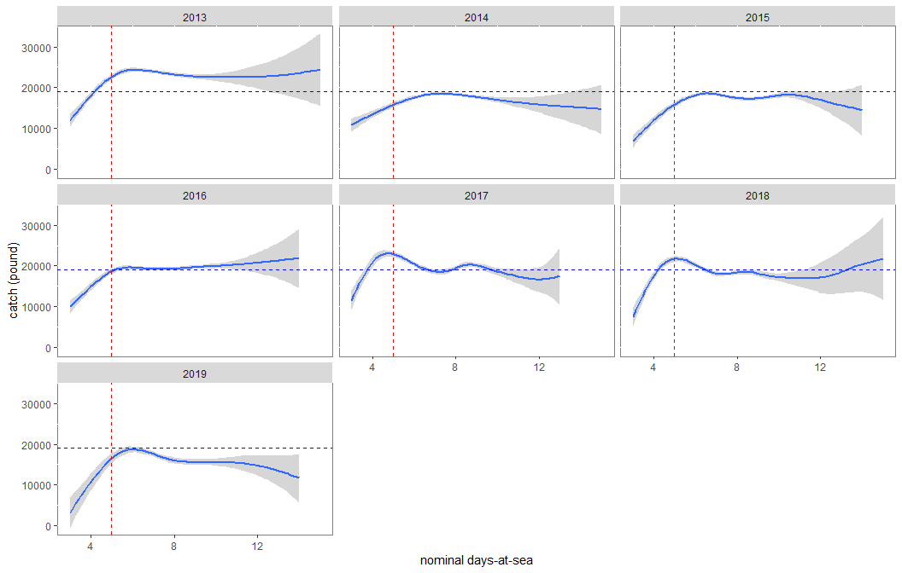

# Analysis of seabob biomass

# Seabob biomass The biomass (raw) landed between 2013-2018 ranged between 15,820 MT (2014) to 21,892 MT (2013). Following a sharp decline of 6,072 MT in 2014 compared to 2013, there was was a stendy increase in bimass landed between 2014 to 2017 i.e. 15,820 MT to 21,658 MT; a difference of 5,838 MT. In 2018 the biomass again declined, this time by 2,667 MT. Due to the short time series of data available for 2019, no comparison was possible.

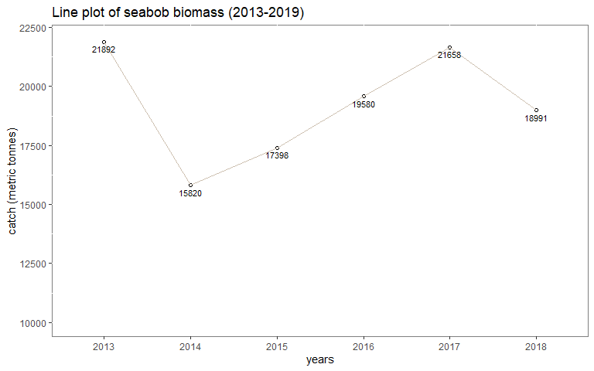

# Cumulative frequency plots of shrimp size classes

# Shrimp size category data

The size categories were grouped as follows from largest to smallest size categories as far as practicable. The groups created were as follows in the this order; Group names (size range) and components:

1. sizeOne (90-130) - P&D 90-110, P&D 110-130, 90-110, 90-120, 110-130  
2. sizeTwo (130-150) - 130-150  
3. sizeThree (150-230) - 150-200, 150-230  
4. sizeFour (200-350) - 200-300, 250-350  
5. sizeFive (300-500) - 300-400, 300-500  
6. Broken (BK)  
7. Mixed - 150-UP, Grade 2, Over 400, Over 900, MM, Second Q M, Second Q S  
8. Sour (Spoiled)

From the frequency plot of the largest size category (sizeOne) below it can be seen from the gently sloping lines that smaller amount of the said size category were caught in between 2017:2019 (last 3 years) when comapred to the earlier years. ## Cumulative frequency plot of the largest seabob category (90-130) 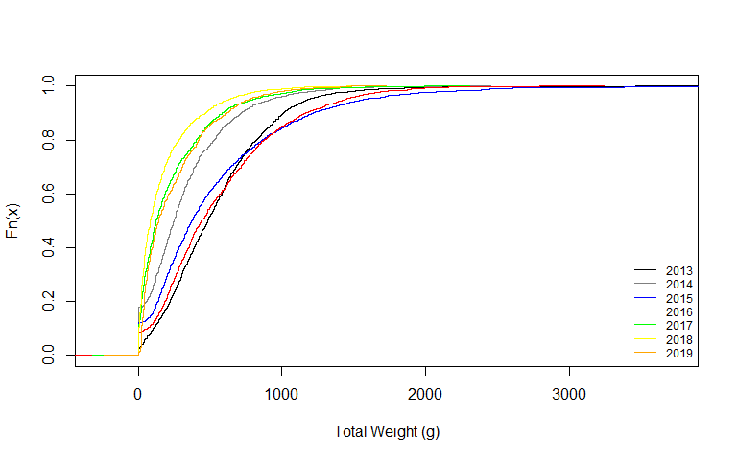

# Plot of seabob size distribution by company.

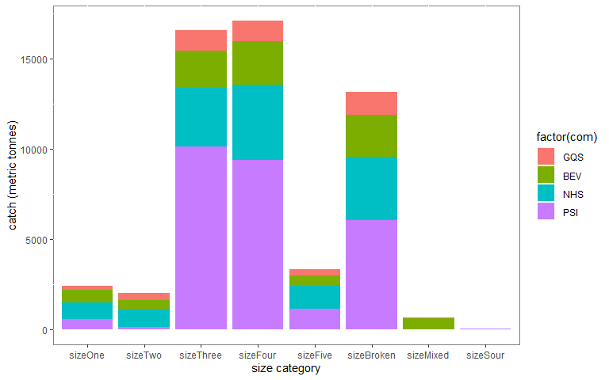

# Data plots against the Reference Points

The catch variable was used to create a new variable which grouped the catch according to reference points from the Harvest Control Rule. The groupings were as follows:

Target Reference Point (TRP) - >19,000 lbs  
 Trigger Reference Point (TP) - 17,000 lbs : 18,999 lbs  
 Limit Reference Point (LP) - 10,000 lbs : 16,999 lbs  
 Below the LRP (Very Low) - <10,000 lbs

## By Company

Most of the trip landings/catch were grouped into the Target Reference Point (TRP) grouping and the least in the “Very Low” category, across all companies. Noteworthy is the fact that for one of the companies (NHS), the Limit Reference Point category was higher than the TRP.

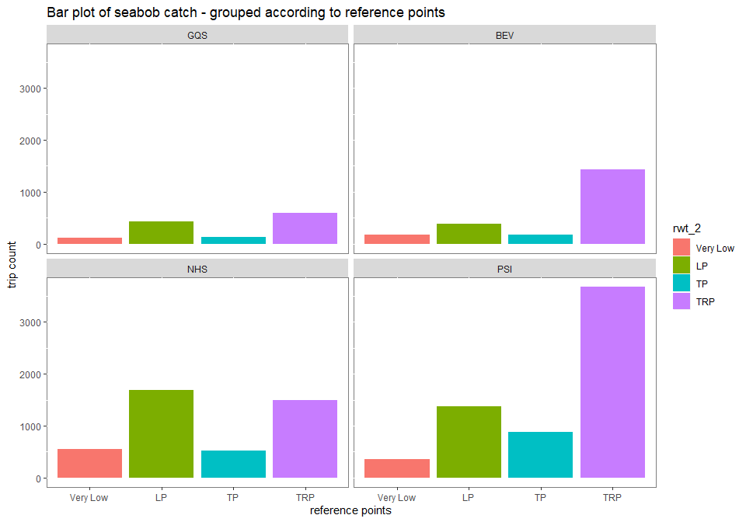

## By month

Analysis of this grouping revealed that there was a greater proportion of higher catchs per fishing trip across years (2013-2019) in earlier months of the year in comparison to latter months when measured against the other defined reference points.

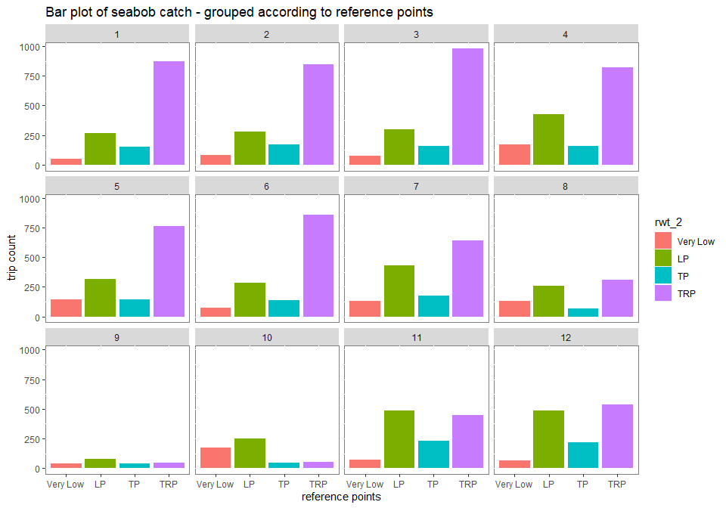

# Analysis of fishing effort

## Days-at-sea annual distribution

There was a steady increase in total vessel ndas from 2013 to 2017, with a decline in 2018 compared to 2017. The overall ndas distribution ranged from a minimum of 14,955 in 2013 to a maximum of 17,414 ndas in 2017.

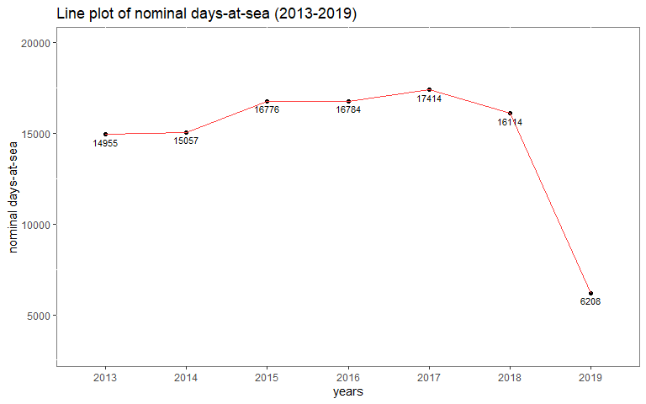

## Average days-at-sea by company

The mean trip length between 2013 to 2019 ranged from 5.89 (6) to 9.09 (9) days at sea. The mean trip length (appx. 8 ndas) was similar for three of the four companies, with the exception being PSI (appx. 6 ndas). The mean trip length was highest in 2019 for two of the three operational companies and the second highest for the remaining company when compared to the other years. There was no das data for BEV for 2019 as the company closed operations in 2018. 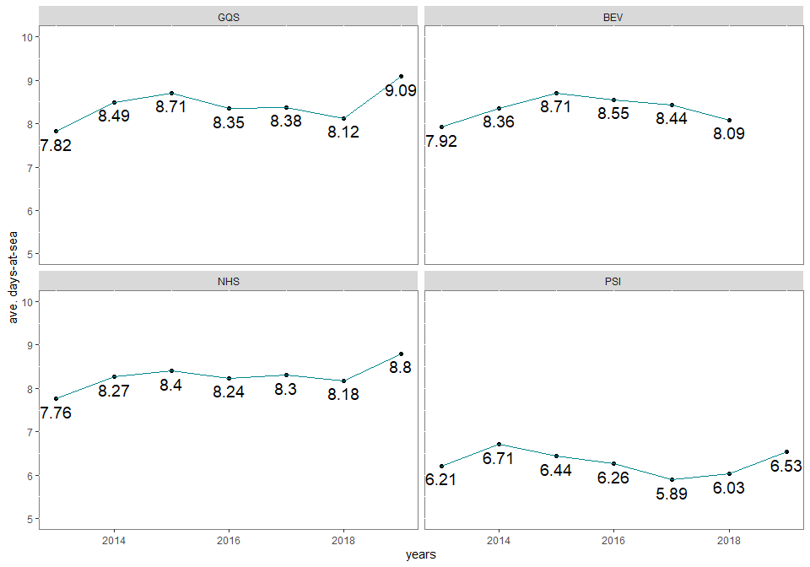

## Trip distribution by nominal days-at-sea

Observed fishing trips between the period 2013 to 2019 showed a normal distribution with the primary lengths of fishing trip being seven, eight, nine and six days respectively i.e. over 2000 trips each. Trip lengths of five and ten days were the next most represented (over 1000 entries) in the data set. All other trip lengths recorded (i.e. 3, 4, 11:15) were below 400 trips respecitively.

## ndas Freq  
## 1 3 208  
## 2 4 421  
## 3 5 1340  
## 4 6 2346  
## 5 7 2977  
## 6 8 2668  
## 7 9 2586  
## 8 10 1152  
## 9 11 226  
## 10 12 44  
## 11 13 8  
## 12 14 6  
## 13 15 3  
## 14 Total 13985

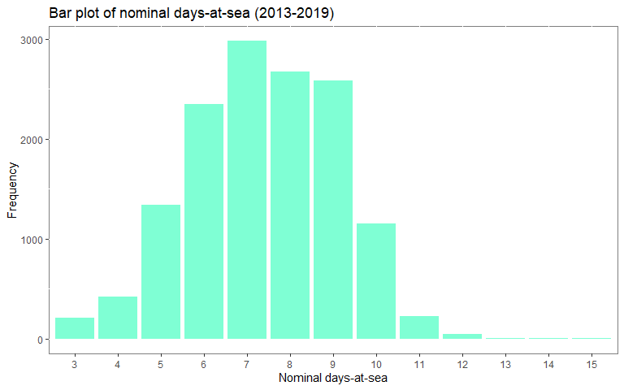

## Trip distribution by months

Fishing trips over months have been fairly evenly distributed. The months of March and April recorded the number of monthly trips i.e. above 1,500 respectively. The lowest recorded trips were between the months August to October, which is as a result of the annual closed season for seabob fishing.

## mon Freq  
## 1 1 1348  
## 2 2 1376  
## 3 3 1517  
## 4 4 1583  
## 5 5 1365  
## 6 6 1354  
## 7 7 1378  
## 8 8 769  
## 9 9 210  
## 10 10 528  
## 11 11 1245  
## 12 12 1312  
## 13 Total 13985

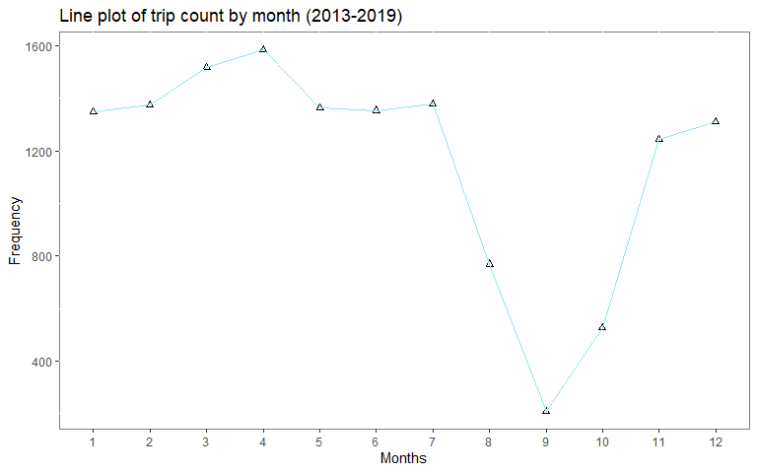

## Trip distribution by years

There was an observed decline in fishing trips in 2014 compared to the year 2013 i.e. 2,106 to 1,993 (113 less). This was follwed by a steady increase in fishing trips from 2013 to 2017; an overall increase by 399 trips (i.e. 1,993 to 2,392). This was followed by a decline of 159 trips in 2018 compared to 2017.

## yr Freq  
## 1 2013 2106  
## 2 2014 1993  
## 3 2015 2214  
## 4 2016 2249  
## 5 2017 2392  
## 6 2018 2233  
## 7 2019 798  
## 8 Total 13985

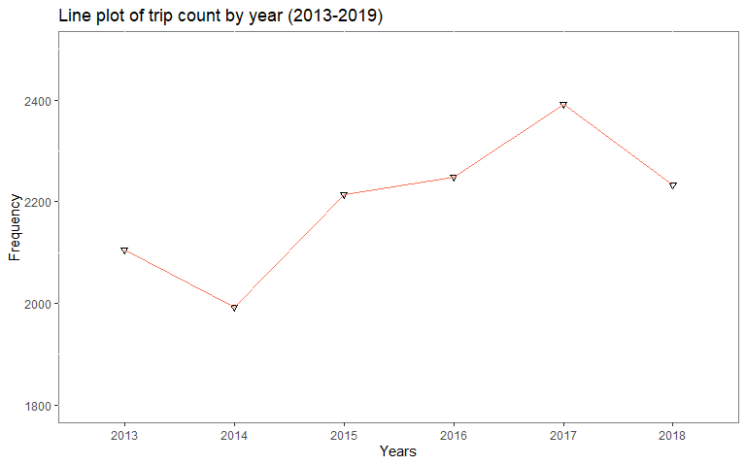

# ANALYSIS OF CATCH AND EFFORT (JANUARY TO APRIL)

# Biomass

The biomass for the period 2013 to 2019 (January to April) ranged from a minimum of 5,508 in 2019 MT to a maximum of 9,780 MT in 2017. Over that period these was steady increase between 2013 to 2017, except for the year 2016 where the biomass was lower than the two preceed years. Following the sharp recovery of biomass in 2017 from the decline in 2016, there drop in 2018 followed by a sharp decline in 2019 (lowest recorded biomass).

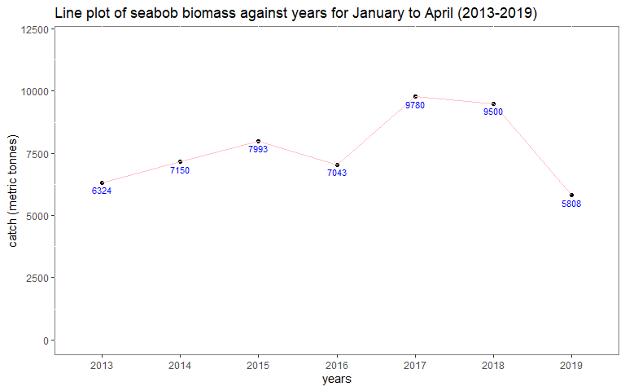

# Fishing effort

## Trips

## yr Freq  
## 1 2013 629  
## 2 2014 824  
## 3 2015 875  
## 4 2016 821  
## 5 2017 945  
## 6 2018 956  
## 7 2019 774  
## 8 Total 5824

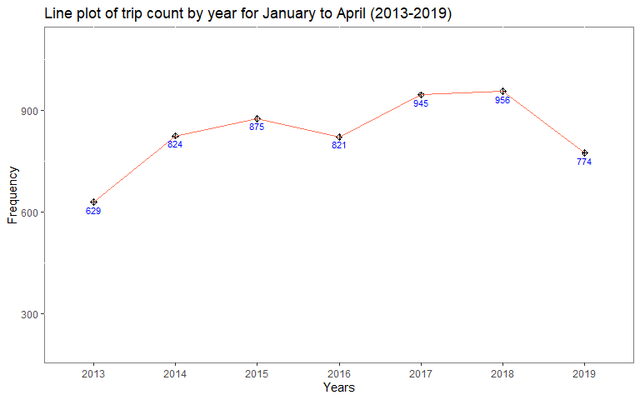

# Fishing effort

## Days-at-sea

Fishing effort continually increased from 4,793 ndas (2013) to 6,765 ndas in 2018 (the highest recorded), except for 2016 when there was a decrease compared to the previous year. The annual ndas recorded were all in excess of 6000 ndas except for the year 2013 (4,493). Noteworthy is the fact that 2019`s ndas (6,008) was the penultimately lowest value.

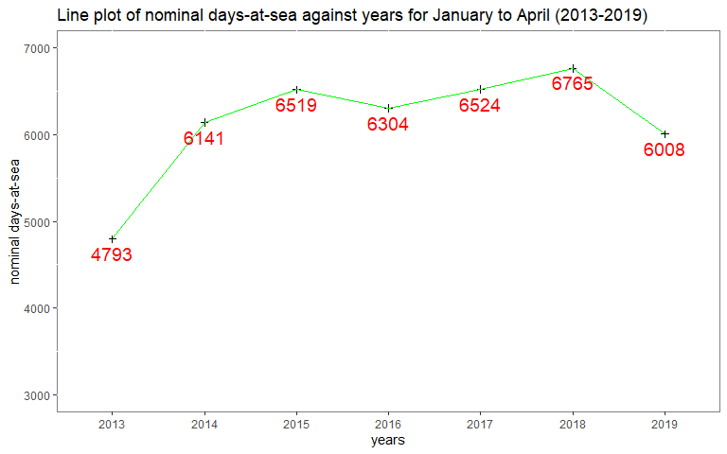

# Average days-at-sea by company from January to April (2013-2019)

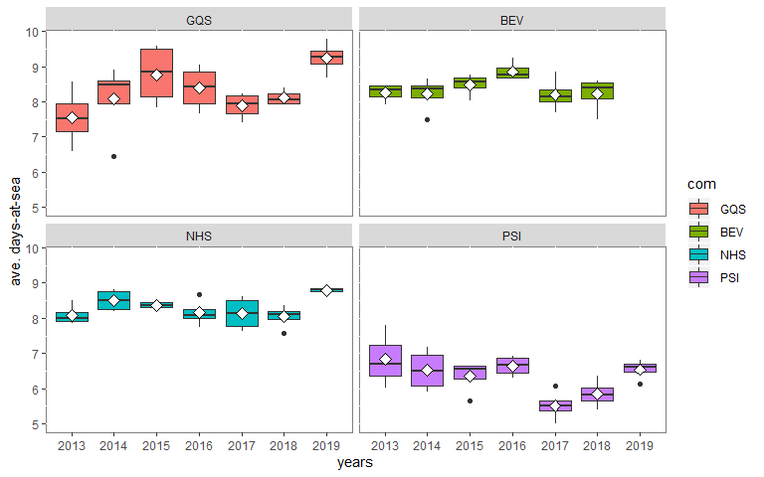

# Catch-per-unit-effort (biomass/effort)

The catch per standardized fishing day ranged from 580 kg/sdas in 2019 (the lowest) to 862 kg/sdas in 2017 (the highest). There was a steady increase and decrease trend in successive years. The steepest increase occurred between 2016 (661 kg/sdas) and 2017 (862 kg/sdas); a 30% jump i.e. by 201 kg. The sharpest decrease occurred between 2018 (808 kg/sdas) and 2019 (580 kg/sdas); a 28% decline i.e. 228 kg. 